PERSONAL INFORMATION | Aulia Elma Rabbika
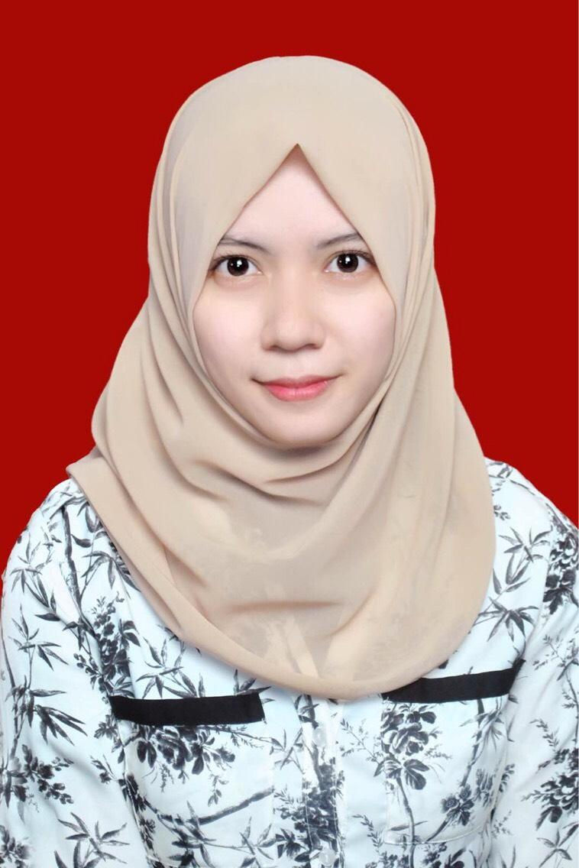 |   Jl. Margonda Raya, Gang Pepaya No. 33, Depok, Jawa Barat  Postal Code : 16424, Indonesia
 |  +62 812 5050 8191

auliaelmaa@gmail.com

Skype aulia elma
 | Sex Female | Weight 50 kg | Height 158 cm | Date of birth 28 January 1996 | Nationality Indonesia

ACTIVITY | Master Student of Industrial Psychology in University of Indonesia

EDUCATION BACKGROUND

2013 – 2017 | Bachelor of Psychology | GPA : 3.46 of 4.00
2013 – 2017 | Lambung Mangkurat University, South Kalimantan – Indonesia  Jl. Ahmad Yani KM. 35 - 36 Simpang Empat, Banjarbaru City, South Kalimantan – Indonesia.  Phone : +62 (0511) 3306603  Website : www.unlam.ac.id
2013 – 2017 | Dissertation Title :  - Relationship between State Boredom and Academic Flow of Students in SMA Global Islamic Boarding School.
PERSONAL SKILLS

Mother Language Indonesian
Other Language English (520 on TOEFL ITP)

Communication skills | Good communication skills gained through my experience as :  - Announcer in 98.0 Nirwana FM Banjarbaru (2018)  - Master of ceremony of Behaviour Modification Training by Psychology of Lambung Mangkurat University (2016)  - Speaker of Educational Training in Kindergarten by Psychology of Lambung Mangkurat University. (2015)  - Speaker of introduction of Psychology for new undergraduate students (2014-2015)  - Speaker of LKMM (Training of Student Skill Management). Faculty scale (2014)  - Speaker of Educational Behavioural Information in Desa Pumpung as famous village to Diamonds panning in South Kalimantan (2014)

Organisational / managerial skills | - Staff of Youth Abroad Festival 2017 in Banjarmasin presented by Studec International (2017)  - Staff of Public Service and Society Dedication of Psychology Student Organization (HIMA Psikologi) of Lambung Mangkurat University (2014-2015)  - Chief of a Movement of Caring Unlucky Students (2014-2015)  - Chief of a Movement of Caring Woman and Children called “GEMA PERAK” (2014-2015)  - Staff of National Seminar of Psychology “Psychology and Crime”. Conducted by Psychology Student Organization of Lambung Mangkurat University (2015)  - Staff of Behaviour Modification Training by Psychology of Lambung Mangkurat University (2015)  - Staff of Diesnatalis Medical Faculty of Lambung Mangkurat University (2015)  - Chief of Mother’s Day Celebration, participated by 150 Mothers and their Children (2014)  - Staff of Talk Show “Stop the Sexual Abuse of Children and Adolescents”. Conducted by Psychology Student Organization of Lambung Mangkurat University (2014)  - Staff of Seminar of Educational and Profession “How Can I be My Best Self”. Conducted by Psychology Student Organization of Lambung Mangkurat University (2014)  - Staff of Wonderful Psychology Event. Conducted by Psychology Student Organization of Lambung Mangkurat University (2014)

Hobbies / Interest | - Freelancer in Biro Psikologi Talenta Aditama and Biro Psikologi Imajiner Talenta – Tester on Psychological Test & Interviewer for Recruitment  - Reading many kinds of books, such as fiction and non-fiction novel, self help, personal development, encyclopedia.  - Writing a short story or a critical thinking.  - Cooking.  - Dancing, including modern and traditional dance.  - Singing.  - Listening music.  - Watching movies.  - Playing Logic games, Adventure games, Simulation games.

ADDITIONAL INFORMATION

Honours and awards  Seminar(s)  Workshop(s)  Training(s)  Volunteering(s) | - Best solution for Nation Essay Youth Worldwide (2017)  - National finalist of national essay competition. Co’s Schooling for Productive Gold Generations in Indonesia. Awarded by National University of Singapore (2016)  - Second Place of Scientific Essay Competition. I am as Creative and Innovative Student. Awarded by Medical Faculty of Lambung Mangkurat University (2013)  - Youth Seminar “My Love, My Country”. Conducted by by Nanang Galuh of Banjarbaru City (2017)  - National Seminar of Moeslem “Stairway to Jannah”. Conducted by KSI Asy Syifa of Medical Faculty of Lambung Mangkurat University (2016)  - Seminar of Industrial and Organizational Psychology “The Role of Psychology in Human Resources Development” (2014)  - Seminar Islamic 2SLR (2014)  - National Seminar Entrepreneurship “Reach a Dream of One Million Dollars with Merry Riana”. Conducted by Psychology Student Organization of Lambung Mangkurat University (2013)  - Share the Sense, Share the Story. Conducted by KSI Asy Syifa of Medical Faculty of Lambung Mangkurat University (2013)  - Educational Workshop with Taufik Kasturi, S.Psi., M.Si., PhD, (Increase Optimism with Positive Psychology) Presented by HIMPSI Kalsel collaborated IPK Kalsel (2018)  - Educational Workshop with Prof. Dr. Frieda Maryam Mangunsong Siahaan, M.Ed., Psikolog (Implementation and Educational Inclusive Issues in College) (2017)  - Motor Function Optimization for Children with Special Needs. Conducted by Physiotherapy Community of Indonesia (2017)  - Handling Children with Special Needs. Conducted by Psychology Community of Indonesia (2016)  - Workshop of Professional Education and Research “Be a Qualified Future Psychologist with Research” (2016)  - Political South Kalimantan Student Forum (2014)  - Leadership Training by Nanang Galuh of Banjarbaru City 2017 (2017)  - Asia Pacific Future Leader Conference 2016 (2016)  - Training BEI (Behavioral Event Interview) for Assesing Competency (2016)  - Training Assesing Competency (2016)  - Training for Personality Test (2016)  - Behaviour Modification Training by Psychology of Lambung Mangkurat University (2016)  - LKMM (Training of Student Skill management) (2013)  - As a Volunteer in Youth Worldwide Chapter Malaysia. (2017)  - As a Volunteer in Foundation for Children with Special Needs “Melati Anak Bangsa”. (2016 – 2018)

