Molecular Dynamics Simulation on Creep Mechanism of Nanocrystalline Cu-Ni Alloy

ABSTRACT− Creep mechanism is an important mechanism that happens to a material when it is subjected to a high temperature and high pressure. It shows the ability of material during and extreme application. This test is already done experimentally in many materials. However, understanding the creep mechanism at the atomic level is challenging due to the limitation of the apparatus, but the improvement of mechanical properties is expected can be done at such level. Here, the creep mechanism of nanocrystalline Cu-Ni alloy is demonstrated in terms of molecular dynamics simulation. The result shows a significant impact of both temperature and pressure. The mechanisms are supported by the dislocation, especially by those atoms around the grain boundary. Quantitative analysis shows a more significant difference of creep-rate at a higher level of the parameters. This study has successfully demonstrated the mechanism of creep at the atomic scale and may be used for improving the mechanical properties of the material.
KEYWORD : Molecular dynamics simulation; creep behaviour; Cu-Ni alloy.

ITRODUCTION
A single system of most metallic materials such as Au, Ag, Cu, Al, Ni, and so forth are suffering from their ability to accommodate complex demand ranging from the manufacturing industry, electronic devices, and transportation like aviation. Such system cannot be used to satisfy every aspect of the demands that come from respective industry, either due to economic efficiency issue in general, or could be due to the fact that it does not have all the electronic, magnetic, catalytic, biological, and mechanical properties necessary for a specific application, whilst binary systems often provide a unique solution due to their unusual properties and phase transition compared to a single system (Mizushima et al. 1996, Brillo and Egry 2005, Baskaran et al. 2006, Ahmed et al. 2008, Studt et al. 2012, Sopousek et al. 2014, Teeriniemi et al. 2015, Gubicza et al. 2018). Cu-Ni is one of the binary systems that nowadays widely used in a various range of application, such as metal foams due to its excellent bending strength and superior anti-corrosion (Mizushima et al. 1996, Ji et al. 2014, Gubicza et al. 2018), a catalyst for hydrogenation of CO to methanol (Studt et al. 2012) and other nanoparticles for catalyst (Ahmed et al. 2008), thin films (Mizushima et al. 1996, Cao et al. 2017), and more recently has been used for inducing the transformation of chemical vapour deposition (CVD) grown bilayer graphene into fluorinated single-layer diamond (Bakharev et al. 2019). Such a wide range of applications needs a well-understanding of their properties; thus, the utilization of this material could be derived appropriately.
The properties of such materials are well understood at a macro and micro-scale through several tests and experiments. However, in order to improve the properties of materials, some phenomena have to be understood at a smaller scale, such as nano-scale or even atomic-scale (Zaenudin et al. 2018). This is a very challenging issue in the experimental domain. As an alternative, numerical simulation is developed to overcome this issue with several approaches, including continuum scaling, finite element analysis, and atomistic simulation. These techniques have their advantages and disadvantages. Other than that, in atomic-scale, molecular dynamics simulation has been proving its reliability in giving an insightful idea of understanding the phenomena that are hard to be explored by both theoretical and experimental investigation.
Several studies have been reported in terms of creep mechanism by employing MD simulation. One of the first studies that have employed MD simulation to study creep is a study conducted by Keblinski et al. (Keblinski et al. 1998). Several phenomenological behaviours correspond to the Arrhenius diffusion equation and Coble formula which relates to grain boundary activated diffusion energy is well-identified by this study, although several idealizations correspond to the grain boundary along with polycrystalline silicon has to be adopted. A deeper understanding related to grain growth on the grain boundary of Palladium diffusion-creep is contributed to Haslam et al. (Haslam et al. 2004). Grain boundary (GB) diffusion creep, indicated by the Coble-creep mechanism, is accommodated by geometrically necessary GB sliding which eventually leads to several types of deformation that they called as Region 1 and Region 2. The other two studies have revealed the dependence of grain size (Wang et al. 2012) along with time, stress and temperature (Yang et al. 2016) during creep deformation. In order to gain an understanding of the entropic effect during steady-state creep deformation, Wang et al. (Wang et al. 2013) have performed MD simulation of nanocrystalline Cu. They have demonstrated that the activation entropy could contribute multiplicative factors as high as 103 and 109 for creep governed by GB dislocation nucleation and for GB diffusion. Investigation on the influence of the addition of a specific element to a binary alloy has been conducted by (Pal et al. 2017). They conclude that the addition of Zr on nanocrystalline Ni accelerate the amorphization during creep deformation and that nanocrystalline Ni with segregated Zr presents a longer time during creep process compared to nanocrystalline Ni with randomly distributed Zr atoms. Recently, Sun et al. (Sun et al. 2019) has demonstrated the shift mechanism of creeping behavior in nanocrystalline Ni-Al alloy which results the effect of temperature, stress, and grain size on the creep rate, especially in tertiary creep stage. However, some phenomena of creep diffusion for particular material like Cu-Ni alloy has not clearly identified. Therefore, this study aims to tackle this issue.

SIMULATION PROCEDURE
Three software is used in this study for running the two steps of the whole study. For the simulation itself, the LAMMPS (Plimpton 1995) software package is used. This software used to calculate and solve the basis of classical molecular dynamics simulation, Newtonian equation of motion, with an efficient algorithm. Completed with its ensemble condition, this software is a complete solution for running a classical molecular dynamics simulation. This software nowadays is widely used by researchers to study the phenomena of materials at the atomic level, especially for metallic materials. Another step is the post-processing of the obtained data after running the simulation. In this study, the simulation data is processed by using OVITO (Stukowski 2010) software to view the atomic movement thus showing the transformation of the bulk materials due to constant stress and temperature during a creep test. In this software, several structural analysis techniques also including, thus improving the ease of identification of structural defects and deformation of metallic crystalline materials.
Figure 1. Simulation model of Cu-Ni alloy with 10 nm × 10 nm × 10 nm: (a) a view assisted by Common Neighbor Analysis (CNA) for separating view between each grain and (b) atom-type view with Cu (red) and Ni (blue) atoms.
The simulation model as depicted in Figure 1 consists of Cu-Ni alloy with roughly 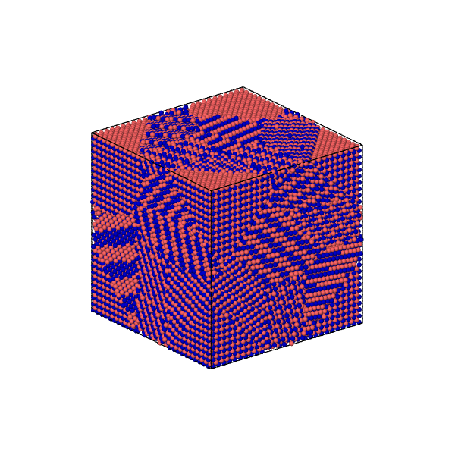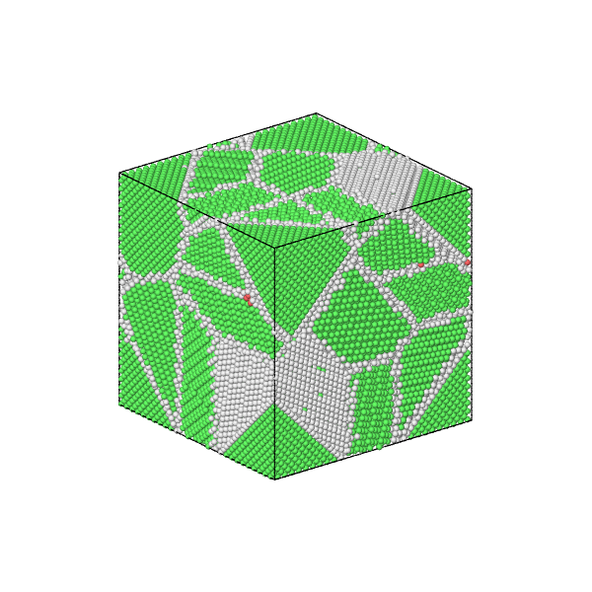the same atom number each element (50% of Cu and 50 % of Ni). The size of the simulation model is 10 nm × 10 nm × 10 nm in x, y, and z-direction, respectively. The grain distribution and modelling are generated by Voronoi tessellation by using AtomSK software (Hirel 2015) in which all of the bulk model volumes are divided into ten similar size grains with random grain orientation. At the first model, the model is not a perfect cube, but a random shape corresponding to its grain size and orientation. However, AtomSK software facilitates to wrap the model in such a way to meet the perfect cube form. The software facilitates to wrap the model in such a way that it is then wrapped into a perfect cube. In order to allow atoms to move freely due to induced force, periodic boundary condition (PBC) is applied in all three directions. If the atoms exceed the boundary by the induced force during creep test, then it will occur in the opposite direction with the same internal properties, thus it will maintain the number of atoms consisting in the system and reducing the boundary effect in which usually not involved in the experimental work since the boundary has to be defined for such simulation. Two parameters are employed in this study, they are temperature and pressure, with three levels each of them. The details of the simulation parameters following the sample number given for the sake of easiness are listed in Table 1.
z
y
x
(a)
(b)

Table 1. Simulation parameters
Sample No. | Temp (K) | Press (GPa)
S1 | 1000 | 1
S2 | 1100 | 1
S3 | 1200 | 1
S4 | 1000 | 1.25
S5 | 1000 | 1.5
S6 | 1100 | 1.25
S7 | 1100 | 1.5
S8 | 1200 | 1.25
S9 | 1200 | 1.5

Typically, classical MD simulation consists of three steps. They are initialization, production, and relaxation. These three steps though could use the same statistical ensemble, running different instances. In this study, first, the system is initialized with the NPT ensemble with room temperature and atmospheric pressure. This step is performed for a quite short time only to obtain an equilibrium condition; thus, the system is ready for the next production step. After the system is reaching an equilibrium state, constant pressure and temperature as listed in Table 1 were applied. This stage is performed for 300 ps under the NPT ensemble. The data regarding the relationship between strain and time which corresponds to the creep test is generated along with the simulation. Subsequently, the system is cooled until ended with the relaxed final shape of the bulk material after a creep test. It has to be noted here that, during the initialization step, how long the simulation takes to prepare the equilibrated system is depending on the complexity of the system. The more complex and bigger system will take effect on how long the system will be equilibrated and ready for the creep test. It could be monitored in LAMMPS by the energy associated with the system, typically potential and kinetic energy. If the system is running for creep test whilst it is not equilibrated properly, it may be resulting in the inaccuracy of the output resulted.
Although the reliability of MD simulation is now been recognized in many fields of study, in practice, several different factors may determine the quality of the simulation result and eventually the reliability of the simulation. For metallic materials, an interatomic potential plays a crucial role in determining the quality of the simulation. Embedded Atom Method (EAM) (Daw and Baskes 1984, Foiles et al. 1986) is one of the interatomic potentials that is widely used for metallic materials. In this study, the EAM interatomic potential developed by Onat et al. (Onat and Durukanoǧlu 2014) for Cu-Ni alloy is adopted. Following the EAM formalism, the total energy is defined by:

$$E_{tot} = \frac{1}{2} \sum_{ij}{Ф_{a_{i}-a_{j} }(r_{ij})}+ \sum_{i}{F_{a_{i}}({\overline{ρ}}_{i})} (1)$$

Here $Ф_{a_{i}-a_{j} }$ is a pair of interaction potential as a function of the distance $r_{ij}$ between atoms i and j that have chemical sorts $a_{i}$ and $a_{j}$ (= A or B) and $F_{a_{i}}$ is the embedding energy of an atom of a chemical sort $a_{i}$ as a function of the host electron density ${\overline{ρ}}_{i}$ induced at site i by all other atoms in the system.

RESULTS AND DISCUSSIONS
Several aspects that correspond to the creep test performance and its detailed features described in this section, including time evolution of the sample during creep test, creep test results that are defined by the time-strain curve, and its creep rate. Also, for the sake of completeness, the relationship between the applied pressure and creep rate finally discussed.

- Time evolution during creep-test
Due to constant temperature and pressure, the bulk materials experience compressive stress and then deformation may occur in which the magnitude of deformation depends on the applied parameters and the properties of the material itself. As depicted in Figure 2, a higher level of temperature and pressure which correspond to sample S3 experience the highest magnitude of deformation compared to S1 and S3. A perfect crystalline structure and grain boundary at 0 ps have changed over time. The green-coloured atom which indicates an FCC crystalline structure has deformed randomly and made the structure have more white-coloured atoms, which have a random structure. Diffusion at around the grain boundary, which initiated immediately after the parameters are applied, is one of the responsible effects, besides the deformation of the bulk material, that changed the crystalline structure of every grain.
As listed in Table 1, several simulations have been performed and the relationship between time and strain, representing the ability of the materials to remain their crystalline structure under certain extreme temperature and pressure, have been obtained. This time evolution which connected to the strain value of the materials over time, time-strain curve, is depicted in Figure 2 and Figure 3. Specifically, the comparison of the effect of temperature on the time-strain curve is depicted in Figure 2, whilst Figure 3 shows the comparison of the effect of pressure.
Figure 3. Creep test results of Cu-Ni alloy at the various temperature with the pressure of (a) 1 GPa, (b) 1.25 GPa, and (c) 1.5 GPa.

Figure 2. Time evolution of creep test for the samples with a pressure of 1 GPa at various temperature of 1000 K, 1100 K, and 1200 K, referred to as S1, S2, and S3, respectively.

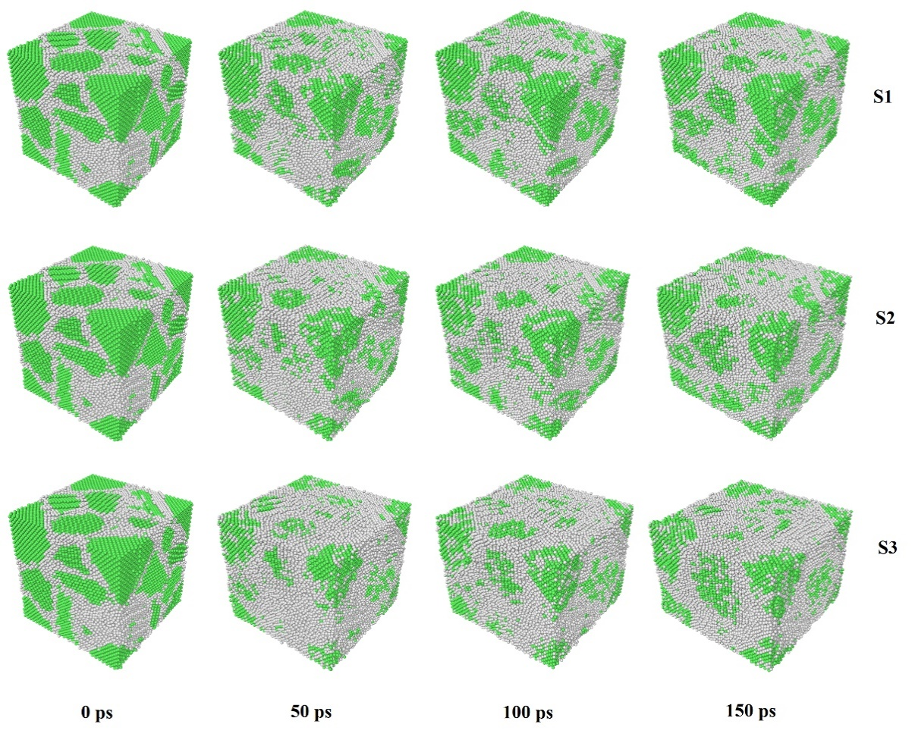
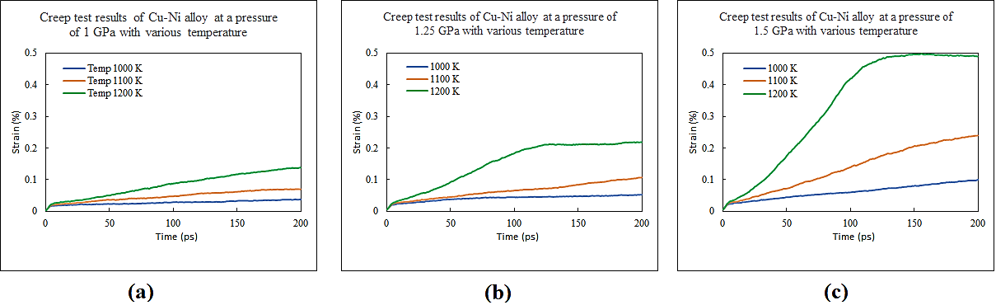
Both Figure 3 and Figure 4 show an increasing effect, indicated by the significant difference between Figure 3(a), 3(b) and 3(c), and Figure 4(a), 4(b), and 4(c). Figure 3(b) and 3(c) indicated a plateau stage where there are no further strain changes after. However, this plateau stages do not affect the diffusion at around the boundary as depicted before in Figure 2. The diffusion at around the boundary still happen.

- Quantitative creep test analysis
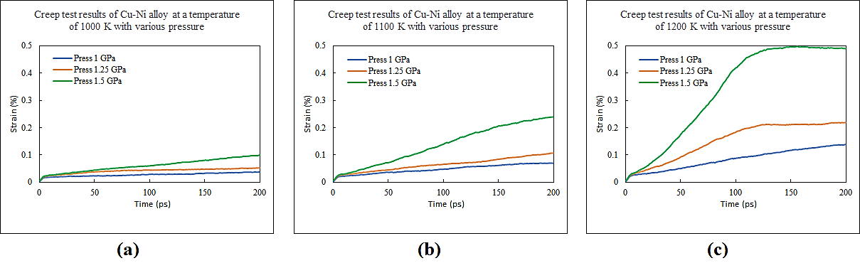
There is also a more accurate way to determine the dominant mechanisms of creep deformation between the applied temperature quantitatively, that is by comparing the creep-rate between the sample. This is done by calculating the slope of tangent in the creep test curve. Table 2 shows the creep-rate of the corresponding sample number. It is shown that the highest value of both pressure and temperature during the creep test showing the significant difference, and hence defining the significant mechanism during the creep test. Although several samples show a bit different (S5 & S6) behaviour, it is not changing the behaviour of the creep at a higher rate.
Figure 4. Creep test results of Cu-Ni alloy at the various pressure with the temperature of (a) 1000 K, (b) 1100 K, and (c) 1200 K.

Another way to quantitatively evaluate the creep behaviour is that by comparing them in terms of the curve of creep rate vs. pressure, and then find out the trendline in which some regression method could be used. Figure 5 shows the pressure vs. creep rate curve combining with its trendline. A more significant slope of tangent can be seen directly in this curve. Although the influence of both temperature and pressure already discussed, and as other comparison techniques presented then the more its behaviour occur since the number of sample of each parameter is limited (only 3 x 3) then it is possible to find out the other behaviour bellow and upper from the presented parameter here at this paper.
Figure 5. Pressure vs. creep-rate and its corresponding trendline for various temperature tests.

Table 2. Creep rate of corresponding sample number.
Sample No. | Creep Rate (S-1)
S1 | 6.85 × 105
S2 | 3.01 × 106
S3 | 6.08 × 106
S4 | 3.41 × 106
S5 | 4.7 × 106
S6 | 4.33 × 106
S7 | 1.16 × 107
S8 | 1.58 × 107
S9 | 3.72 × 107

CONCLUSIONS
The conclusion can be drawn as follow:
- Temperature and pressure have a significant impact on the creep-mechanism;
- Time evolution shows that the mechanism of creep is due to the dislocation of the atoms, especially those near the grain-boundary;
- Quantitative analysis shows the same behaviour, and that higher level of parameter makes the difference more significant.

ACKNOWLEDGEMENTS
The authors would like to thank Institut Teknologi & Kesehatan Jakarta for the support throughout this project. This project is funded by the Ministry of Education and Culture under the scheme of Research of Early Career Lecturer (PDP) No. B/87/E3/RA.00/2020.

REFERENCES
Ahmed, J., Ramanujachary, K. V., Lofland, S.E., Furiato, A., Gupta, G., Shivaprasad, S.M., and Ganguli, A.K., 2008. Bimetallic Cu-Ni nanoparticles of varying composition (CuNi3, CuNi, Cu3Ni). Colloids and Surfaces A: Physicochemical and Engineering Aspects, 331 (3), 206–212.
Bakharev, P. V, Huang, M., Saxena, M., Lee, S.W., Joo, S.H., Park, S.O., Dong, J., Camacho-Mojica, D., Jin, S., Kwon, Y., Biswal, M., Ding, F., Kwak, S.K., Lee, Z., and Ruoff, R.S., 2019. Chemically Induced Transformation of CVD-Grown Bilayer Graphene into Single Layer Diamond. Nature Nanotechnology, (Cmcm).
Baskaran, I., Sankara Narayanan, T.S.N., and Stephen, A., 2006. Pulsed electrodeposition of nanocrystalline Cu-Ni alloy films and evaluation of their characteristic properties. Materials Letters, 60 (16), 1990–1995.
Brillo, J. and Egry, I., 2005. Surface tension of nickel, copper, iron and their binary alloys. Calphad Computer Coupling Of Phase Diagrams And Thermochemistry, 0, 2213–2216.
Cao, P., Short, M.P., and Yip, S., 2017. Understanding the mechanisms of amorphous creep through molecular simulation. Proceedings of the National Academy of Sciences of the United States of America, 114 (52), 13631–13636.
Daw, M.S. and Baskes, M.I., 1984. Embedded-atom method: Derivation and application to impurities, surfaces, and other defects in metals. Physical Review B.
Foiles, S.M., Baskes, M.I., and Daw, M.S., 1986. Embedded-atom-method functions for the fcc metals Cu, Ag, Au, Ni, Pd, Pt, and their alloys. Physical Review B.
Gubicza, J., Jenei, P., Nam, K., Kádár, C., Jo, H., and Choe, H., 2018. Compressive behavior of Cu-Ni alloy foams: Effects of grain size, porosity, pore directionality, and chemical composition. Materials Science and Engineering A, 725 (April), 160–170.
Haslam, A.J., Yamakov, V., Moldovan, D., Wolf, D., Phillpot, S.R., and Gleiter, H., 2004. Effects of grain growth on grain-boundary diffusion creep by molecular-dynamics simulation. Acta Materialia, 52 (7), 1971–1987.
Hirel, P., 2015. Atomsk: A tool for manipulating and converting atomic data files. Computer Physics Communications.
Ji, K., Zhao, H., Zhang, J., Chen, J., and Dai, Z., 2014. Fabrication and electromagnetic interference shielding performance of open-cell foam of a Cu-Ni alloy integrated with CNTs. Applied Surface Science, 311, 351–356.
Keblinski, P., Wolf, D., and Gleiter, H., 1998. Molecular-dynamics simulation of grain-boundary diffusion creep. Interface Science, 6 (3), 205–212.
Mizushima, I., Chikazawa, M., and Watanabe, T., 1996. Microstructure of electrodeposited Cu-Ni binary alloy films. Journal of the Electrochemical Society, 143 (6), 1978–1983.
Onat, B. and Durukanoǧlu, S., 2014. An optimized interatomic potential for Cu-Ni alloys with the embedded-atom method. Journal of Physics Condensed Matter, 26 (3).
Pal, S., Meraj, M., and Deng, C., 2017. Effect of Zr addition on creep properties of ultra-fine grained nanocrystalline Ni studied by molecular dynamics simulations. Computational Materials Science, 126, 382–392.
Plimpton, S., 1995. LAMMPS [online]. Journal of Computational Physics.
Sopousek, J., Vrestal, J., Pinkas, J., Broz, P., Bursik, J., Styskalik, A., Skoda, D., Zobac, O., and Lee, J., 2014. Cu-Ni nanoalloy phase diagram - Prediction and experiment. Calphad: Computer Coupling of Phase Diagrams and Thermochemistry, 45, 33–39.
Studt, F., Abild-Pedersen, F., Wu, Q., Jensen, A.D., Temel, B., Grunwaldt, J.D., and Norskov, J.K., 2012. CO hydrogenation to methanol on Cu-Ni catalysts: Theory and experiment. Journal of Catalysis, 293, 51–60.
Stukowski, A., 2010. Visualization and analysis of atomistic simulation data with OVITO-the Open Visualization Tool. Modelling and Simulation in Materials Science and Engineering, 18 (1).
Sun, Z., Liu, B., He, C., Xie, L., and Peng, Q., 2019. Shift of creep mechanism in nanocrystalline NiAl alloy. Materials, 12 (16).
Teeriniemi, J., Taskinen, P., and Laasonen, K., 2015. First-principles investigation of the Cu-Ni, Cu-Pd, and Ni-Pd binary alloy systems. Intermetallics, 57, 41–50.
Wang, Y.J., Ishii, A., and Ogata, S., 2012. Grain size dependence of creep in nanocrystalline copper by molecular dynamics. Materials Transactions, 53 (1), 156–160.
Wang, Y.J., Ishii, A., and Ogata, S., 2013. Entropic effect on creep in nanocrystalline metals. Acta Materialia, 61 (10), 3866–3871.
Yang, X.S., Wang, Y.J., Zhai, H.R., Wang, G.Y., Su, Y.J., Dai, L.H., Ogata, S., and Zhang, T.Y., 2016. Time-, stress-, and temperature-dependent deformation in nanostructured copper: Creep tests and simulations. Journal of the Mechanics and Physics of Solids, 94, 191–206.
Zaenudin, M., Mohammed, M.N., and Al-Zubaidi, S., 2018. Molecular dynamics simulation of welding and joining processes: An overview. International Journal of Engineering and Technology(UAE), 7 (4), 3816–3825.

